Tetraethylammonium Salts as Solid, Easy to Handle Ethylene Precursors and Their Application in Mizoroki–Heck Coupling
Eleni Papaplioura, Maëva Mercier, Michael E. Muratore, Tobias Biberger, Soufyan Jerhaoui, Michael Schnürch
J. Org. Chem. 2024, 89, 7, 5126–5133
Substrate | Compound number on paper | ELN entry | NMR
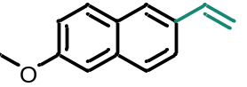 | 2 | epapapli-298 (0.2 mmol) | EPW_298 2/200
 | 2 | epapapli-315 (1 mmol) | EPW_315 1/2
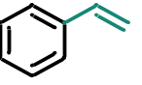 | 3 | epapapli-296 (I) | EPW_296 1
 | 3 | epapapli-453 (Br) | PCC00937 10
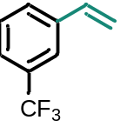 | 4 | epapapli-440 | PCC00891 10
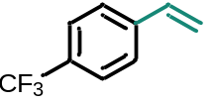 | 5 | epapapli-441 | PCC00882 10
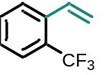 | 6 | epapapli-312 | EPW_312 1
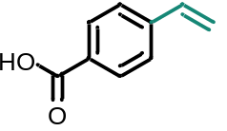 | 7 | epapapli-442 | PCC00892 10
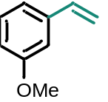 | 8 | epapapli-443 | PCC00871 10
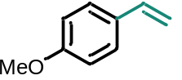 | 9 | epapapli-444 | PCC927 11
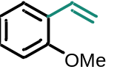 | 10 | epapapli-445 | PCC00961 10
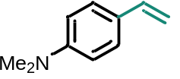 | 11 | epapapli-446 | PCC00930 10
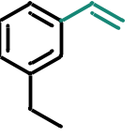 | 12 | epapapli-447 | PCC00939 10
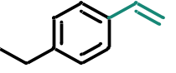 | 13 | epapapli-448 | PCC00931 11
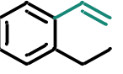 | 14 | epapapli-449 | PCC00932 11
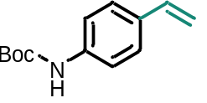 | 15 | epapapli-317 | EPW_317 1
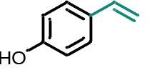 | 16 | epapapli-450 | PCC00900 10
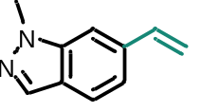 | 17 | epapapli-303 | EPW_303 6/4
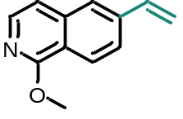 | 18 | epapapli-304 | EPW_304 1/2  (sjerhao 1156)
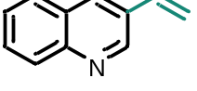 | 19 | epapapli-311 | EPW_311 2/3
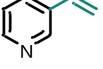 | 20 | epapapli-451 | PCC00911 11
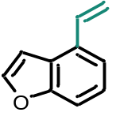 | 21 | epapapli-464 | EPW_966TU 20/200
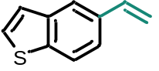 | 22 | epapapli-302 | EPW_302 3/300
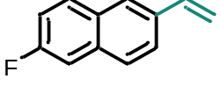 | 23 | epapapli-295 | EPW_295 10/11/40

