Gasification of Heavy Metal–Contaminated Biochar: Experimental Investigation and Thermodynamic Analysis
Nastaran Abbaspour*, Naeimeh Vali², Towhid Gholizadeh³, Daniela Tomasetig⁴, Andrzej Szlęk⁵, Agnieszka Korus⁵, Franz winter¹

¹ Institute of Chemical, Environmental and Bioscience Engineering, TU Wien, Vienna, Austria
²Swedish Centre for Resource Recovery, University of Borås, Borås, Sweden
³Department of Power Engineering and Turbomachinery, Silesian University of Technology, Gliwice, Poland
⁴Institute of Chemical Technologies and Analytics, TU Wien, Vienna, Austria
⁵Department of Thermal Technology, Silesian University of Technology, Gliwice, Poland

List of contents:
S1. Gas evolution profiles for biochar gasification
S2. Dry-gas composition of the gaseous products from biochar gasification: effect of temperature on the average gas composition
S3. Dry-gas composition of the gaseous products from biochar gasification: effect of reaction time on the average gas composition
S4. Raman spectrum of pyrolytic and activated birch biochars
Tables:
ST1. Content of inorganics in birch biomass harvested from the contaminated and uncontaminated areas
ST2. Summary of the activation tests
ST3. Elemental analysis of pyrolyzed and activated biochar (on a dry basis)
ST4. Moisture, ash and ultimate (elemental) analysis of contaminated birch biomass
ST5. List of elements and solution compound compositions included in the thermodynamic databases used for equilibrium modelling
ST6. Content of selected inorganics in pyrolyzed and activated biochars
ST7. BET surface area, total pore volume, and average pore diameter of activated biochars

S1. Gas evolution profiles for biochar gasification

S2. Dry-gas composition of the gaseous products from biochar gasification: effect of temperature on the average gas composition

S3. Dry-gas composition of the gaseous products from biochar gasification: effect of reaction time on the average gas composition

S4. Raman spectrum of pyrolytic and activated birch biochars
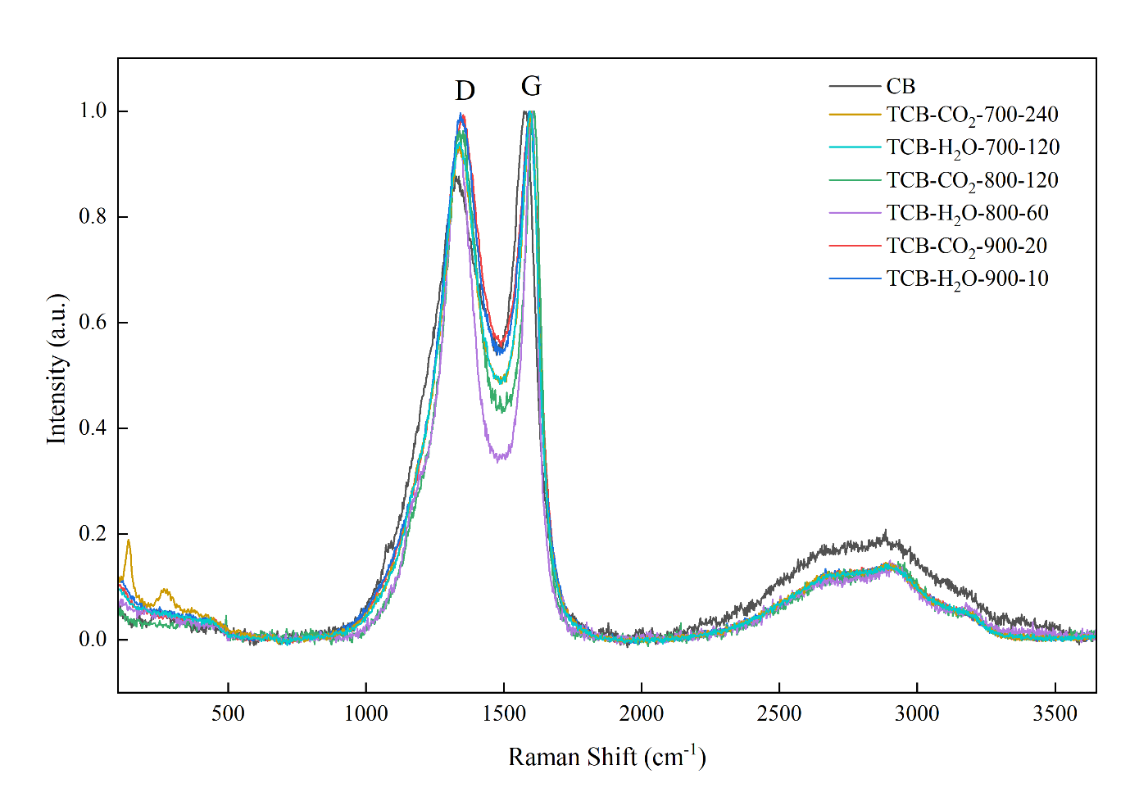

ST1. Content of inorganics in birch harvested from the contaminated and uncontaminated areas [1]
Elements | Contaminated Birch (mg/kg) | ± | Uncontaminated Birch (mg/kg) | ±
Ag | 0.8 | 0 | 0.5 | 0.3
Al | 92 | 10 | 65 | 11
As | 2.3 | 0.1 | 1.2 | 0.3
Ba | 15 | 0 | 29 | 0
Ca | 4014 | 122 | 9109 | 811
Cd | 88.9 | 2.8 | 1.2 | 0.1
Co | 0.4 | 0 | 0.1 | 0.1
Cr | 12 | 3 | 8 | 1
Cu | 36 | 1 | 7 | 1
Fe | 241 | 7 | 133 | 6
K | 1567 | 28 | 2104 | 144
Mg | 498 | 4 | 424 | 12
Mn | 43 | 1 | 18 | 0
Mo | 1.8 | 0.6 | 1.2 | 0.3
Na | 239 | 6 | 233 | 17
Ni | 6 | 2 | 3 | 0
P | 454 | 2 | 501 | 7
Pb | 1863 | 47 | 23 | 1
Sb | 2.3 | 0.1 | 2.3 | 0.2
Sn | 2.7 | 0.2 | 0 | 0.6
Ti | 3.7 | 0.1 | 2.9 | 0.1
Zn | 1580 | 39 | 308 | 41
Si | 1130 | 260 | 951 | 250
Hg | 0.094 | 0.002 | 0.01 | 0.001

ST2. Summary of the activation tests
No | Biochar Type | Atmosphere | Temperature (℃) | Reaction time(min) | Abbreviation
1 | CB | CO₂ | 700 | 240 | TCB-CO₂-700-240
2 | CB | 50/50 vol.% H₂O/CO₂ | 700 | 120 | TCB-H₂O-700-120
3 | CB | CO₂ | 800 | 120 | TCB-CO₂-800-120
4 | CB | 50/50 vol.% H₂O/CO₂ | 800 | 60 | TCB-H₂O-800-60
5 | CB | CO₂ | 900 | 20 | TCB-CO₂-900-20
6 | CB | 50/50 vol.% H₂O/CO₂ | 900 | 10 | TCB-H₂O-900-10
7 | B | CO₂ | 800 | 120 | TB-CO₂-800-120
8 | B | 50/50 vol.% H₂O/CO₂ | 800 | 60 | TB-H₂O-800-60

ST3. Elemental analysis of pyrolyzed and activated biochar (on a dry basis) [2]
Sample name | C (Wt.%) | ± | H (Wt.%) | ± | N (Wt.%) | ± | S (Wt.%) | ± | O (Wt.%) | ± | Sum
B | 70.418 | 0.10 | 2.48 | 0.01 | 1.29 | 0.00 | 0.29 | 0.01 | 13.06 | 0.17 | 87.55
CB | 70.790 | 0.03 | 2.11 | 0.02 | 1.01 | 0.01 | 0.65 | 0.01 | 12.24 | 0.10 | 86.81
TB-H₂O-800-60 | 66.92 | 0.16 | 0.89 | 0.01 | 0.81 | 0.00 | 0.00 | 0.00 | 17.92 | 0.86 | 86.56
TB-CO₂-800-120 | 71.00 | 0.02 | 0.77 | 0.01 | 1.89 | 0.01 | 0.03 | 0.01 | 16.81 | 0.38 | 90.51
TCB-H₂O-700-120 | 78.61 | 0.34 | 1.02 | 0.06 | 0.98 | 0.00 | 0.09 | 0.02 | 10.95 | 0.14 | 91.65
TCB-CO₂-700-240 | 77.42 | 0.33 | 0.92 | 0.02 | 1.67 | 0.02 | 0.14 | 0.02 | 12.18 | 0.13 | 92.34
TCB-H₂O-800-60 | 77.55 | 0.26 | 0.94 | 0.01 | 0.84 | 0.01 | 0.11 | 0.05 | 11.80 | 0.53 | 91.24
TCB-CO₂-800-120 | 77.57 | 0.17 | 0.74 | 0.01 | 1.76 | 0.01 | 0.11 | 0.04 | 12.32 | 1.19 | 92.50
TCB-H₂O-900-10 | 81.14 | 0.56 | 0.79 | 0.04 | 1.06 | 0.02 | 0.11 | 0.04 | 10.47 | 0.15 | 93.57
TCB-CO₂-900-20 | 81.50 | 0.47 | 0.83 | 0.14 | 1.36 | 0.02 | 0.14 | 0.05 | 10.21 | 0.47 | 94.03

ST4. Moisture, ash and ultimate (elemental) analysis of contaminated birch biomass

Parameter | Value | Unit / basis
Moisture | 3.13 | wt% (as received)
Ash | 3.3 | wt% (dry basis)
C | 49.8 | wt% (dry basis)
H | 6.61 | wt% (dry basis)
O | 41.14 | wt% (dry basis)
N | 0.72 | wt% (dry basis)
S | 0.53 | wt% (dry basis)
Cl | 0.11 | wt% (dry basis)

ST5. List of elements and solution compound compositions included in the thermodynamic databases used for equilibrium modelling
Parameter | Input data for thermodynamics equilibrium calculations
Elements | C, H, O, N, S, Cl, Al, Ca, Fe, K, Mg, Na, P, Si, As, Cd, Mo, Cr, Cu, Ni, Mn, Pb, Zn
Databases stoichiometric compounds | Fact PS, FT oxid, FTsalt
Databases gas compounds | Fact PS, HSCA
Solution phases | Nepheline (Na,K)AlSiO₄), Feldspar (Na,K)AlSi₃O₈ - CaAl₂Si₂O₈ Slag-A  SiO₂ + (Na,K)AlO₂ + (Na₂, K₂, Cu₂, Pb, Zn)O, Spinel (Al,Co,Cr,Fe,Mg,Ni,Zn)₃O₄, M₂O₃ (Corundum) (Fe,Al,Mn,Cr)₂O, cPyrA, OliveA, MelA, LEU

ST6. Content of selected inorganics in pyrolyzed and activated biochars [2]
Sample name | Al (mg/kg) | ± | Ca (mg/kg) | ± | K(mg/kg) | ± | Pb (mg/kg) | ± | Zn (mg/kg) | ±
CB | 330 | 2 | 20490 | 30 | 8130 | 10 | 6750 | 30 | 3920 | 13
TCB-H₂O-700-120 | 450 | 20 | 27700 | 1190 | 11700 | 360 | 11000 | 170 | 4830 | 80
TCB-CO₂-700-240 | 330 | 20 | 22300 | 930 | 10500 | 10 | 9500 | 100 | 5890 | 130
TCB-H₂O-800-60 | 590 | 10 | 39500 | 700 | 16700 | 100 | 11100 | 200 | 270 | 5
TCB-CO₂-800-120 | 710 | 20 | 37500 | 780 | 17400 | 360 | 8540 | 110 | 830 | 40
TCB-H₂O-900-10 | 540 | 10 | 24900 | 500 | 15100 | 370 | 1660 | 30 | 110 | 10
TCB-CO₂-900-20 | 340 | 10 | 20600 | 660 | 9470 | 220 | 3860 | 50 | 100 | 10

ST7. BET surface area, total pore volume, and average pore diameter of activated biochars
Sample | S _{BET} (m²/g) | V_{t} (cm³/g) | d_{a} (nm)
TCB-CO₂-700-240 | 608.04 | 0.2900 | 1.3205
TCB-H₂O-700-120 | 609.83 | 0.4187 | 1.4606
TCB-CO₂-800-120 | 673.33 | 0.3214 | 1.3808
TCB-H₂O-800-60 | 617.44 | 0.3976 | 1.4976
TCB-CO₂-900-20 | 566.65 | 0.2813 | 1.3084
TCB-H₂O-900-10 | 580.01 | 0.2857 | 1.4986
TB-CO₂-800-120 | 597.03 | 0.2841 | 1.4133
TB-H₂O-800-60 | 533.44 | 0.3783 | 1.6741

References
[1] Abbaspour N, Szlęk A, Winter F, Korus A. Kinetics of model tar decomposition over activated biochar from a heavy metal-contaminated area. Renew Energy 2025;253:123661. https://doi.org/10.1016/j.renene.2025.123661.
[2] Abbaspour N, Jordan C, Tondl G, Wąsik P, Gholizadeh T, Tomasetig D, et al. Activated biochars from heavy metal-contaminated biomass for CO2 capture: Adsorption performance and dominant mechanisms. Journal of CO2 Utilization 2025;101:103217. https://doi.org/10.1016/j.jcou.2025.103217.

* Corresponding author: Nastaran Abbaspour, email: nastaran.abbaspour@tuwien.ac.at

