Supplementary Material
Kinetics of model tar decomposition over activated biochar from a heavy metal-contaminated area
Nastaran Abbaspour¹, Andrzej Szlęk², Franz Winter¹, Agnieszka Korus^{2*}
¹Institute of Chemical, Environmental and Bioscience Engineering, TU Wien
²Department of Thermal Technology, Silesian University of Technology

List of contents:
S1. Isotherms (measured and fitted)
S2. Comparison of the PDS in TCB and TB biochars
S3. Comparison of the XRD pattern of HT-treated and non HT-treated biochars
S4. XRD pattern versus 2Ѳ angle for CB-HT, TCB-HT and TCB-TU800-HT
Tables:
ST1. Content of inorganics in birch harvested from the contaminated and uncontaminated areas
ST2. Elemental analysis and ash content in pyrolytic and thermally activated biochar (on a dry basis, O by diff)
ST3. Summary of conducted tests
ST4. Contents of selected inorganics in both HT and non-HT chars
ST5. Surface area (S) and volume (V) of the fresh, spent and high temperature-treated biochars

S1. Isotherms (measured and fitted)

S2. Comparison of the PSD in TCB and TB biochars

S3. Comparison of the XRD pattern of HT-treated and non HT-treated biochars
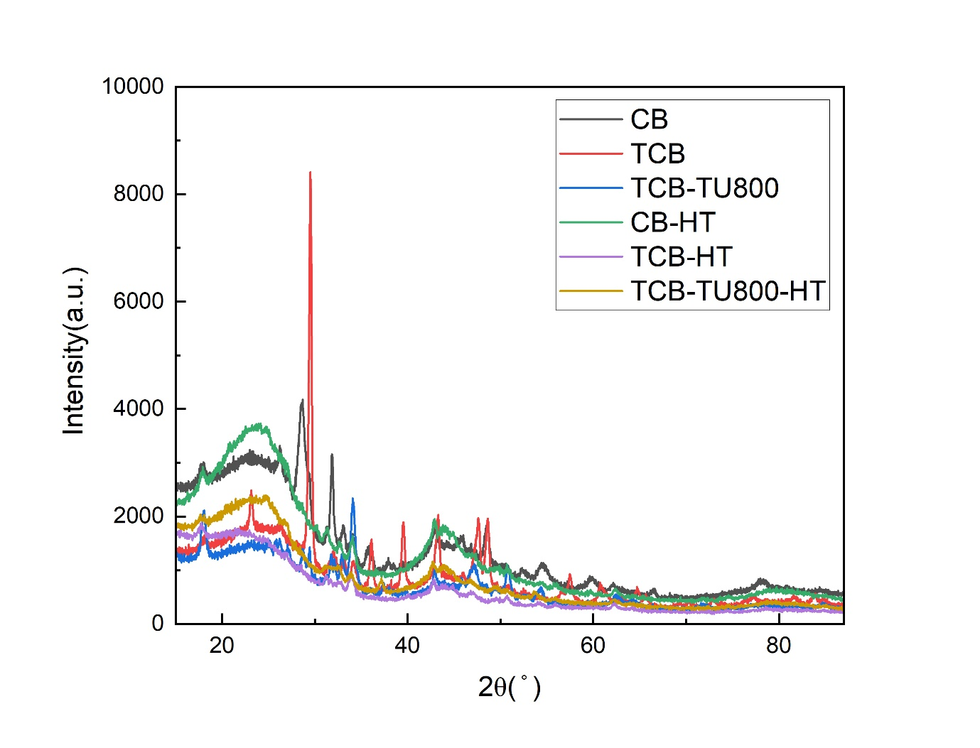

S4. XRD pattern versus 2Ѳ angle for CB-HT, TCB-HT and TCB-TU800-HT
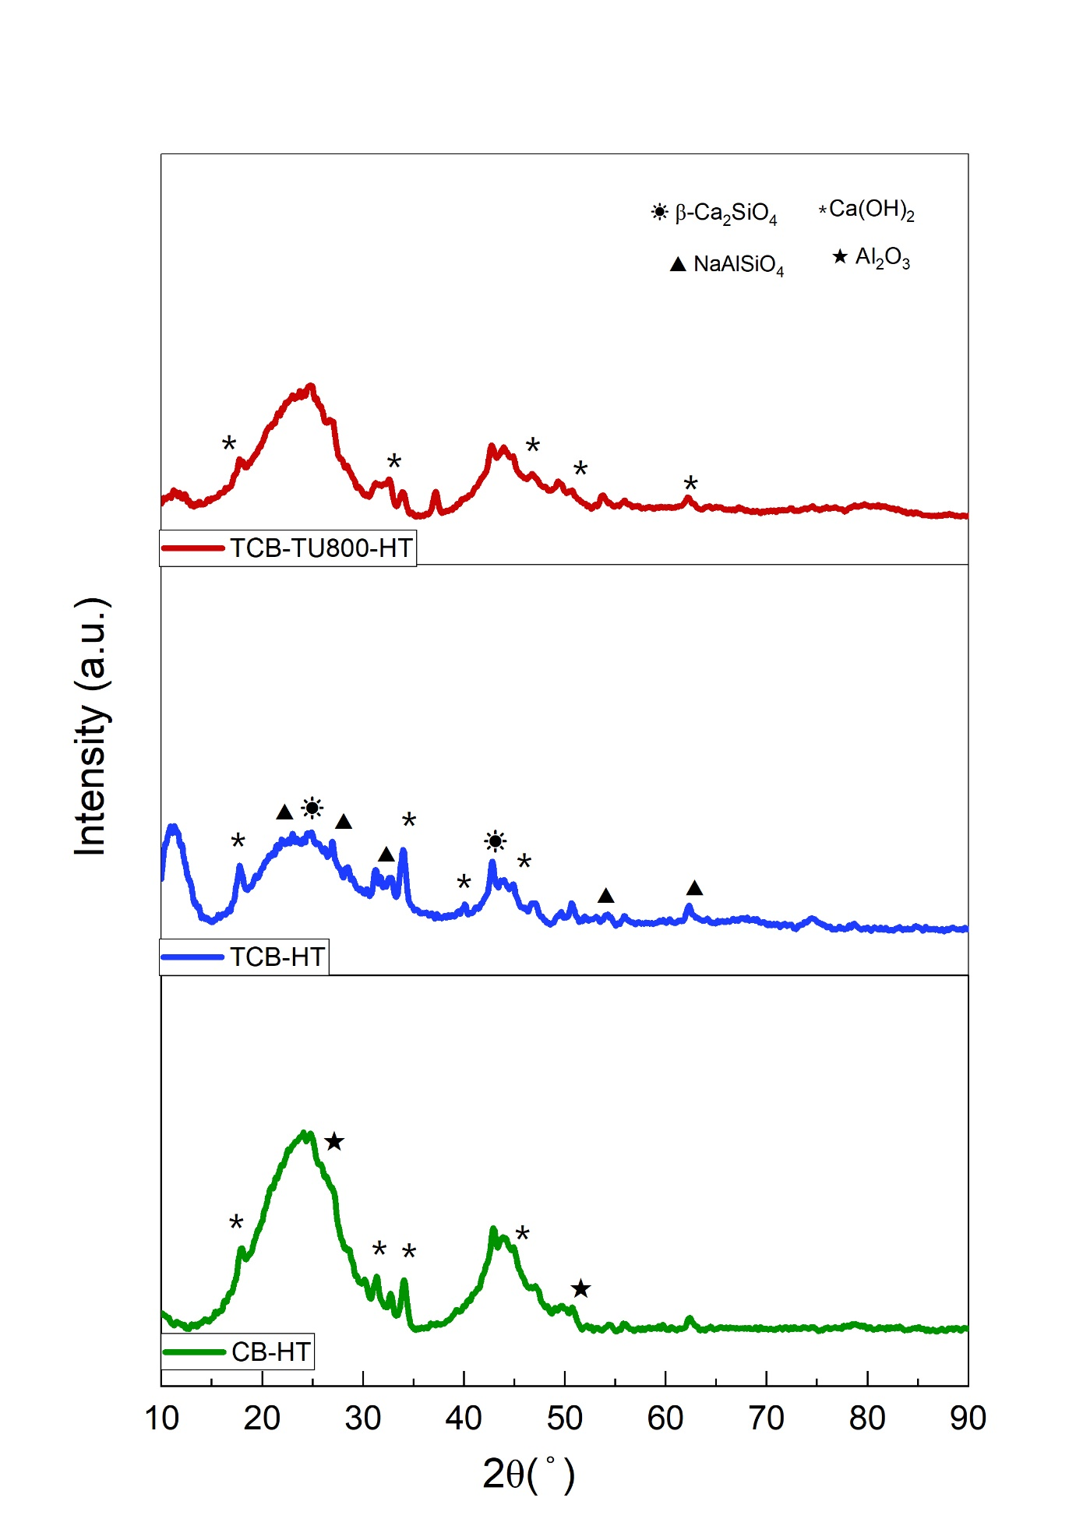

ST1. Content of inorganics in birch harvested from the contaminated and uncontaminated areas
Elements | Contaminated Birch (mg/kg) | ± | Uncontaminated Birch (mg/kg) | ±
Ag | 0.8 | 0 | 0.5 | 0.3
Al | 92 | 10 | 65 | 11
As | 2.3 | 0.1 | 1.2 | 0.3
Ba | 15 | 0 | 29 | 0
Ca | 4014 | 122 | 9109 | 811
Cd | 88.9 | 2.8 | 1.2 | 0.1
Co | 0.4 | 0 | 0.1 | 0.1
Cr | 12 | 3 | 8 | 1
Cu | 36 | 1 | 7 | 1
Fe | 241 | 7 | 133 | 6
K | 1567 | 28 | 2104 | 144
Mg | 498 | 4 | 424 | 12
Mn | 43 | 1 | 18 | 0
Mo | 1.8 | 0.6 | 1.2 | 0.3
Na | 239 | 6 | 233 | 17
Ni | 6 | 2 | 3 | 0
P | 454 | 2 | 501 | 7
Pb | 1863 | 47 | 23 | 1
Sb | 2.3 | 0.1 | 2.3 | 0.2
Sn | 2.7 | 0.2 | 0 | 0.6
Ti | 3.7 | 0.1 | 2.9 | 0.1
Zn | 1580 | 39 | 308 | 41
Si | 1130 | 260 | 951 | 250
Hg | 0.094 | 0.002 | 0.01 | 0.001

ST2. Elemental analysis and ash content in pyrolytic and thermally activated biochar (on a dry basis, O by diff)

 | C (wt.%) | ± | O (wt.%) | H (wt.%) | ± | N (wt.%) | ± | S (wt.%) | ± | Ash (wt.%) | ±
B | 75.67 | 0.05 | 12.55 | 2.21 | 0.02 | 1.73 | 0.05 | 0.098 | 0.004 | 7.76 | 0.95
CB | 79.71 | 0.03 | 8.51 | 2.71 | 0.03 | 1.80 | 0.02 | 0.156 | 0.002 | 7.11 | 1.12
TB | 58.29 | 0.25 | 22.36 | 1.50 | 0.01 | 0.88 | 0.01 | 0.078 | 0.002 | 16.89 | 0.90
TCB | 70.12 | 0.15 | 13.93 | 1.79 | 0.01 | 0.96 | 0.02 | 0.167 | 0.004 | 13.04 | 1.48

ST3. Summary of conducted tests
No | Biochar | Temperature  (℃) | Atmosphere | Compound | Abbreviation
1 | TCB | 800 |  |  | TCB-TU800
2 | TCB | 750 |  |  | TCB-TU750
3 | TCB | 700 | N₂ | Toluene | TCB-TU700
4 | TCB | 650 |  |  | TCB-TU650
5 | TB | 800 |  |  | TB-TU800
6 | TB | 700 |  |  | TB-TU700

ST4. Content of selected inorganics in both HT and non-HT chars

 | CB (mg/kg) | ± | CB-HT (mg/kg) | ± | TCB (mg/kg) | ± | TCB-HT  (mg/KG) | ± | TCB-TU800(mg/kg) | ± | TCB-TU800-HT (mg/kg) | ±
Al | 330 | 2 | 410 | 7 | 590 | 10 | 620 | 10 | 420 | 4 | 520 | 10
Ca | 20490 | 30 | 28440 | 60 | 39500 | 700 | 34700 | 200 | 33390 | 90 | 33000 | 400
K | 8130 | 10 | 14130 | 30 | 16700 | 100 | 15900 | 500 | 13370 | 50 | 15100 | 300
Pb | 6750 | 30 | 7 | 5 | 11100 | 200 | ND (<15) |  | 990 | 10 | ND (<15)
Zn | 3920 | 13 | ND (<1) |  | 270 | 5 | ND (<5) |  | 42 | 1 | ND (<5)
ND – not detected

ST5. Surface area (S) and volume (V) of the fresh, spent and high temperature-treated biochars
 | S_{BET} | S_{Total} | S_{Micro} | S_{Utramicro} | S_{Supermicro} | S_{Meso} | V_{Total} | V_{Micro} | V_{Utramicro} | V_{Supermicro} | V_{Meso}
 | (m²/g) | (m²/g) | (m²/g) | (m²/g) | (m²/g) | (m²/g) | (cm³/g) | (cm³/g) | (cm³/g) | (cm³/g) | (cm³/g)
B | 278 | 503 | 497 | 497 | 0 | 6 | 0.145 | 0.122 | 0.122 | 0.000 | 0.023
CB | 273 | 526 | 522 | 522 | 0 | 4 | 0.145 | 0.126 | 0.126 | 0.000 | 0.019
TB | 548 | 677 | 601 | 485 | 116 | 76 | 0.411 | 0.191 | 0.126 | 0.065 | 0.220
TCB | 646 | 791 | 722 | 575 | 147 | 69 | 0.422 | 0.232 | 0.151 | 0.081 | 0.190
TCB-800TU | 19 | 53 | 42 | 36 | 6 | 11 | 0.053 | 0.014 | 0.011 | 0.002 | 0.040
TCB-750TU | 34 | 310 | 292 | 283 | 8 | 19 | 0.140 | 0.079 | 0.076 | 0.003 | 0.061
TCB-700TU | 70 | 498 | 465 | 435 | 31 | 33 | 0.224 | 0.127 | 0.115 | 0.011 | 0.097
TCB-650TU | 142 | 485 | 428 | 378 | 50 | 57 | 0.278 | 0.125 | 0.097 | 0.028 | 0.154
TB-800TU | 14 | 90 | 82 | 72 | 10 | 8 | 0.059 | 0.026 | 0.022 | 0.004 | 0.033
TB-700TU | 67 | 420 | 388 | 361 | 27 | 32 | 0.206 | 0.106 | 0.096 | 0.010 | 0.100
CB-HT | 46 | 139 | 136 | 136 | 0 | 3 | 0.054 | 0.034 | 0.034 | 0.000 | 0.021
TCB-HT | 347 | 580 | 521 | 521 | 0 | 58 | 0.305 | 0.129 | 0.129 | 0.000 | 0.176
TCB-800TU-HT | 64 | 245 | 229 | 183 | 46 | 16 | 0.128 | 0.068 | 0.050 | 0.018 | 0.060

Corresponding authors: Nastaran Abbaspour, email: nastaran.abbaspour@tuwien.ac.at; Agnieszka Korus, email: agnieszka.korus@polsl.pl

